HISTORY REFERENCING
Referencing your work
Historians reference their work, citing the sources of their information. You must also acknowledge your sources in this way. This involves two tasks.
- You should attach a bibliography of books, articles and other sources to the end of your essays. These should be in alphabetical order by author.
- You should acknowledge any quotations, facts and ideas that you use in your text. It should be possible for the reader to go directly to the source of the quotation, fact or idea by using your reference.
For many years, British historians have used the ‘Oxford referencing system’ which uses superscript numbers in the text (e.g.) which correspond to a footnote at the bottom of the page.
However, more and more often, in journals and books, other systems are used.
In the History Department, we are using a system which mixes footnotes with the APA 7th system, which you will encounter in My Reading and on the University Library website.
We have made this change to make it easier for you to seek assistance in the Library, and so that you can use the APA 7th Reference Builder on the library website.

Link to reference builder: https://www.hud.ac.uk/library/finding-info/apa-referencing/reference-builders/
This is what it looks like, with an example:
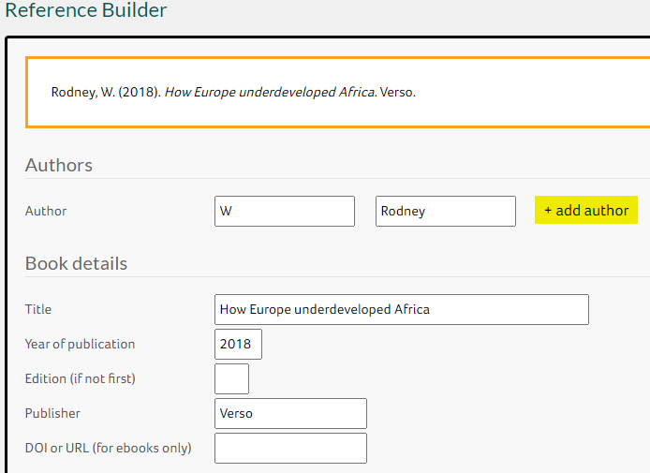
1 Enter book details here
2 Formatted reference appears here: copy and paste into your work
You can copy and paste the information from the library website directly into the Reference Builder and it should render it into the correct format (but always check). You can then copy and paste this into your footnote, adding the page number, and also copy and paste it into the bibliography.

Why mix two systems?
As historians, we need footnotes. Sometimes we might want to put something more than just a book title or an article there. We might want to do a double citation: see footnotes 2 and 5 below. But the standard APA 7th system doesn’t use footnotes – instead, you’d just put the author’s name in brackets in the text (Rousso, 1994) like this. That’s clearly not good enough if you need to make a longer comment or put a reference to an archival document, for example. So the APA 7system isn’t quite enough for historians.
So when you look at the Library pages for APA 7th, you need to remember that historians are different: we use APA 7th as the format for books, articles, chapters etc in the footnotes and in the bibliography, but we put footnotes rather than the author’s name in brackets in the text.

What would the bibliography look like?
References are simply copied and pasted from the footnotes – same format but you exclude the page number.

Archives
APA 7th doesn’t cater for archives. Archival referencing depends very much on the archive itself, the nature of the item you’re consulting, and so it’s more important to follow the principle of the format rather than dictate specifically what it will look like. Just make sure you’re consistent. Here is the principle of the format:

Archive, Place. Box file reference and/or name of file/box/collection/dossier as appropriate. Author, item, date, page.

Examples:
From the National Archives
National Archives (NA). HO 45/10651/2211798. Report on the Royal Commission on Motor Cars, 1906, p. 22.
NA. AIR 37/1012. Letter from Churchill to Portal, 21 May 1944; letter from Portal to Tedder, 22 May 1944; letter from Tedder to Churchill 23 May 1944; letter from Churchill to Tedder, 10 July 1944.
NA. AIR 37/1012. Eisenhower, D. ‘Attacks on civilians’ memorandum to Air Force commanders, 2 June 1944.

Other examples
Brotherton Library, Special Collections, University of Leeds. Refugee Voices: The AJR Audio-Visual Testimony Archive. Interview with Alice Rubinstein (transcript), 2 October 2003.
Hull History Centre (HHC), Kingston upon Hull. L DEX/24 Children’s recollections of the Blitz. Essay by Ida Elsworthy, 9 February 1942.

West Yorkshire Archive Service (WYAS). KC32/1, Florence E. Lockwood diary. Entry for 21 January 1919.

WYAS. KC/65 Belgian refugees committee. Letter from De Couster to Mr Whitehead, 5 March 1919.

Advice
- Use the Reference Builder at first as it will format each type of reference for you. In time you will get the hang of the pattern to use.

- Use Summon or Google Scholar in order to find publication details – e.g. date, place, page span for article or book chapter.

- Don’t forget to add the page number in the footnote (the Reference Builder doesn’t have a box for this so you need to remember): the principle is that any reader should be able to go directly to the quotation, idea or fact that you’ve used.

JOINT PATHWAY STUDENTS: Those taking modules from areas other than History should note that presentation and referencing styles vary according to discipline and you must refer to the relevant handbooks for details.

Top tip: in Word, you can do ALT, I, N, N, Return for a shortcut to enter a footnote!

